Clinical trials using adult stem cells to treat MS
on August 23, 2011 at 6:00 AM, updated August 24, 2011 at 1:38 PM

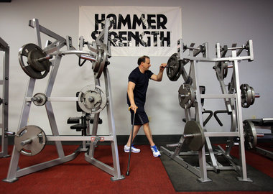Lisa DeJong, The Plain DealerBill White, 46, of North Olmsted, is a regular at the Power House Gym in North Olmsted, despite being diagnosed with multiple sclerosis in 2007. White is the first patient enrolled in a new joint clinical trial of the Cleveland Clinic, University Hospitals and the Case Western Reserve University School of Medicine. The clinical trial is testing to see whether White's own stem cells can be used to help treat MS.
CLEVELAND, Ohio -- Each year in the United States, about 10,000 people are diagnosed with multiple sclerosis. A long-term treatment that not only relieves symptoms but also repairs the damage caused by the disease has eluded researchers.
Now, the Cleveland Clinic, University Hospitals Seidman Cancer Center and Case Western Reserve University are collaborating on a one-of-a-kind clinical trial in the United States, designed to treat, or even reverse, the debilitating effects of multiple sclerosis by using a patient's own adult stem cells.
Mesenchymal stem cells, or MSCs, are found in the bone marrow. More than 150 other clinical trials in the United States and around the world are currently testing MSCs' ability to encourage tissue repair as a way to treat a variety of other conditions such as osteoarthritis, diabetes, emphysema and stroke. Stem cell therapy is already used to treat leukemia, lymphoma and certain blood disorders.
In the Phase One trial here, a patient's MSCs are harvested at UH, carefully cultivated in a special laboratory at CWRU and then injected intravenously back into the patient at the Clinic.
Since June, two patients have undergone the entire process. A third is scheduled to receive an infusion of MSCs on Monday. A total of 24 patients with relapsing or progressively worse MS who have moderate to severe disability will take part in the study over the next two to three years.
The primary aim is to test the feasibility and safety of using the body's own stem cells to treat MS. But researchers also are looking closely for any preliminary evidence that the transplanted cells could moderate the over-active immune system, possibly stopping or even repairing tissue damage.
(A previous version of this story misstated the hoped-for impact on a person's immune system.)
"Ultimately, that is our hope and our goal," said neurologist Dr. Jeffrey Cohen, lead investigator of the trial. Cohen directs the Experimental Therapeutics Program at the Clinic's Mellen Center for Multiple Sclerosis Treatment, which is part of the Clinic's Neurological Institute.
Cleveland ClinicDr. Jeffrey Cohen
The adult stem cells that are being grown are not the embryonic stem cells that for years have been surrounded by controversy and have been a political lightning rod.
"We're avoiding the ethical and practical issues involved with embryonic stem cells," said Cohen, professor of medicine in the Cleveland Clinic Lerner College of Medicine of the CWRU School of Medicine. "Hopefully this will open the door to treat a variety of other neurologic conditions using cells from adults that are relatively easy to obtain."
If promising results lead to a larger, multicenter clinical trial that also yields good outcomes, Cohen said the treatment could be offered in a clinical setting within five to seven years.
Three other Phase One trials in Spain and Iran using adult MSCs to treat multiple sclerosis are, or will soon be, recruiting patients. A fourth Phase One trial, in China, is recruiting patients for a study that is using umbilical cord MSCs to treat MS.
The first patient sees some changes
On June 13, Bill White of North Olmsted became the first patient to undergo the adult stem cell infusion treatment, three months after bone marrow containing a small number of those cells was taken from his hip.
White started noticing disturbing changes in his body about six years ago. A businessman (he owned a flooring business) and fitness enthusiast (a personal trainer, he and his wife, Shannon, also owned a gym), he became uncharacteristically fatigued.
Things he took for granted -- walking, exercising -- were all but impossible.
"My balance was off," said White, 46. "[People] thought I was stoned at work all the time, or drunk. I don't smoke. I don't drink."
Ultimately, work had to go.
White was officially diagnosed with MS in 2007. Scans revealed lesions on White's brain, caused by MS.
Cohen first saw White in late 2008.

About MS and mesenchymal stem cells
Multiple sclerosis is an autoimmune disease that affects the brain and central nervous system. In people with MS, the immune system abnormally attacks the central nervous system, causing damage to the nerve cells and their protective myelin sheath. Most people with MS experience their first symptoms and are diagnosed between the ages of 15 and 50, according to the Multiple Sclerosis Association of America. Women are more likely than men to be afflicted.
Mesenchymal stem cells are primitive cells in the bone marrow that have a wide range of effects. They decrease the activity of immune cells while encouraging tissue repair, both of which may be beneficial in treating multiple sclerosis.
MSCs have been tested as a treatment for a variety of conditions, including graft-versus-host disease, coronary artery disease, nonhealing bone fractures, peripheral arterial disease, acute stroke and spinal cord injury.
Overall experience with MSC transplantation in humans is limited. In 1995, researchers from Case Western Reserve University and University Hospitals Seidman Cancer Center published the first-in-humans trial of MSCs. In 2000, UH Seidman conducted the first-in-humans trial of MSCs in autologous hematopoietic cell (blood/marrow) transplant, followed by the first-in-humans trial of MSCs in allogeneic hematopoietic cell transplant in 2005.

MS and a plant-based diet
A free educational seminar that focuses on how a plant-based diet can help prevent, manage or even reverse the effects of multiple sclerosis and other serious ailments will be held from 9:30 to noon Saturday at Marriott Cleveland East, 26300 Harvard Road, Warrensville Heights. Dr. Linda Bradley, vice chair of obstetrics, gynecology and the Women's Health Institute at the Cleveland Clinic, will be the featured speaker. Call 216-780-0099 to register for the event, which includes breakfast. The 12th annual Kym Sellers Benefit Gala for Multiple Sclerosis will be from 7 p.m. to midnight that night at the Marriott. Tickets are $135 per person. To purchase tickets: thekymsellersfoundation.org.
For more than a year, White endured daily shots of the drug Copaxone in his stomach, in the hopes that the drug would help block the effects of the disease.
Then he tried once-a-week injections of the drug Avonax in an attempt to decrease symptom flare-ups.
That lasted only a few weeks.
Tired of side effects -- White said the medication took away his appetite, causing him to drop more than 50 pounds from his 233-pound frame -- he told Cohen that he wasn't going to take any more drugs.
Cohen first broached the topic of the trial with White in February 2010.
"I was just gung-ho on trying it," White said. "When you get this, you just want to be normal."
More than a year would pass before the trial was ready to enroll White.
After White's stem cells were collected in March, lab technicians grew them in a carefully controlled lab environment. When enough cells were cultivated, they were injected intravenously into his arm.
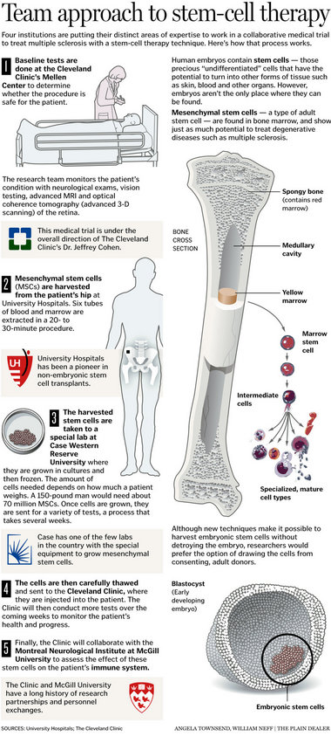View full size
Almost immediately, White saw changes.
"I used to have to use my left arm to lift my left leg up," he said. "Now I can lift [the leg] up on my own."
White still gets tired when he walks, just not as quickly now. His eyesight also has improved, from 20/25 vision to 20/20.
An MRI scan taken during White's most recent Clinic appointment on Aug. 16 showed no new lesions on his brain.
"It's weird, it's like little things," he said last week. "This is just so awesome."
For a while, after getting the MSC infusion, White was a bit worried he was going to be the only patient in the study.
In the weeks that followed, however, he has met two other patients during his frequent trips to the Clinic for blood tests and other close monitoring. A fourth is scheduled to be infused in September.
Other trials in the United States and around the world that test new MS treatments have led to unexpected effects on patients, Cohen said. Sometimes it might cause a heightened allergic reaction or more active disease. Other times, the treatment may be effective but then cause the immune system to be compromised in different ways.
With all of that in mind, the researchers sought to design what Cohen calls a "pretty conservative" study. Because of that, the trial has had a relatively slow start.
Once the fourth enrolled patient has had his/her MSCs transplanted and has been observed for one month, the research team will conduct a formal safety review with an external committee.
"We expect the cell infusion to be safe and uneventful," said Dr. Stanton Gerson, director of the Seidman Cancer Center and director of the National Center for Regenerative Medicine at CWRU. "The kick is not the cell infusion, but the ability of the cells to dampen an immune reaction that is taking place and bothering the patient. The true effect of that may not be seen for months."
If all goes well, the enrollment pace will pick up.
The groundwork for the study goes back nearly a decade when, in 2003, two CWRU colleagues -- biology professor Arnold Caplan and Robert Miller, a neurosciences professor at the medical school -- decided to work together.
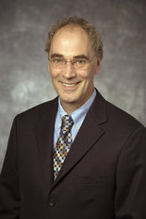CWRURobert Miller
"Had we met five years before, [that pairing] wouldn't have taken place," Miller said.
The timing was right. Advances were happening in the MSC field that interested Miller, an MS researcher.
"It was the first time, I think, that we had talked science together," Miller -- now vice dean for research at the medical school -- said about meeting Caplan at a research showcase. "We had sort of passed each other [before] but had not actually engaged."
In 2006, after a couple of years of refining their experiments, Caplan and Miller's studies involving mice with a version of MS began to bear fruit. Not only did the mice, injected with MSCs from human donors, get better, but there also was no sign of cell rejection.
"We published a couple of papers," Miller said. "At that point, I think we said, 'OK, the next thing is a clinical trial.' That's when I went over and talked with Jeff [Cohen] and Richard Rudick [director of the Clinic's Mellen Center for Multiple Sclerosis Treatment & Research].
"They looked at me . . . 'Do you know what you just said? Do you know how hard that is?' " Miller said.
So hard that it took four years to design a human clinical trial that met with the Food and Drug Administration's approval, and to get the money-- $2.75 million from the U.S. Department of Defense and $1 million from the National Institutes of Health -- to run the trial.
"There are lots of questions," said Miller, who later today will take part in a panel discussion about the neurological applications of adult stem cells. The panel is part of thethree-day MSC 2011 conference taking place in downtown Cleveland. Nearly 300 researchers from across the United States and more than a dozen countries are attending the conference, which ends on Wednesday.
"If this is really going to work, it's going to be spectacular," he said. "We don't understand how it's working, even in the animal models. We know [the MSCs are] driving myelin repair, but we don't know all the molecules involved, all the cells involved.
"I'm hugely excited," Miller said. "How could you not be?"

